**K.V.R. Shinde Shikshan Sanstha’s**

**Shivraj College of Arts, Commerce And**

**D. S. Kadam Science College, Gadhinglaj. (Dist. Kolhapur)**

Certificate

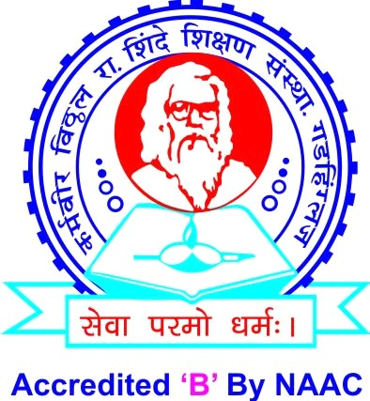

This is to certify that **Mr. Shubham Shivaji mengane or Mr. Omkar Suresh Gavli** has successfully completed the project on the topic **“E-Book Website”** in satisfactory manner for partial fulfillment of degree for the academic year 2021- 22.

To the best of our knowledge and belief the matter presented here is original and has not been submitted elsewhere for the award of any degree.

Place: Gadhinglaj Date:

Examiner

Prof. K. S. Desai (H.O.D)

**K.V.R. Shinde Shikshan Sanstha’s**

##### Shivraj College of Arts, Commerce And

**D. S. Kadam Science College, Gadhinglaj. (Dist. Kolhapur)**

Certificate



This is to certify that the project entitled **“E-Book Website”** submitted by **Mr. Shubham Shivaji Mengane or Mr. Omkar Suresh Gavli**. To partial fulfillment of the requirement of degree of B.C.A. has been prepared under my guidance and supervision in their original work.

To the best of my knowledge and belief, no such work has been previously submitted to the award of any degree in past and is an original work.

Place: Gadhinglaj Date:

Prof. Miss. P.B.Patekari. (Project Guide)

**OUTPUT**



**OUTPUT**

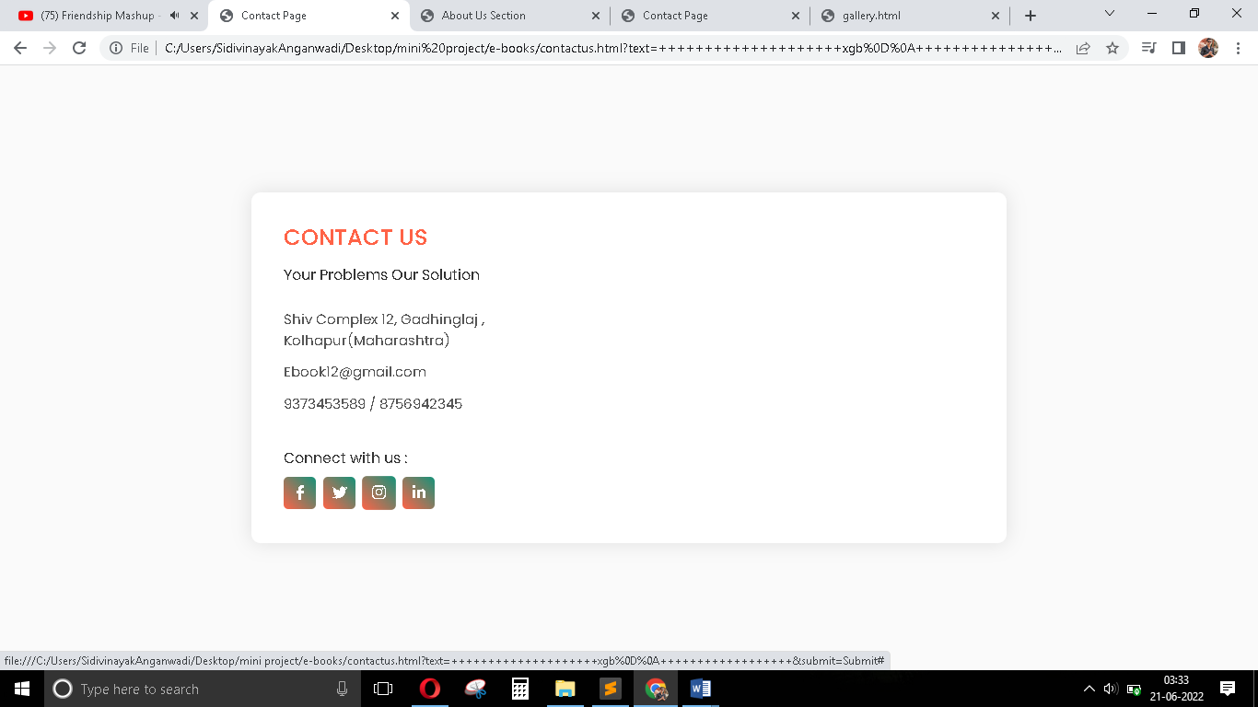

**OUTPUT**



**OUTPUT**

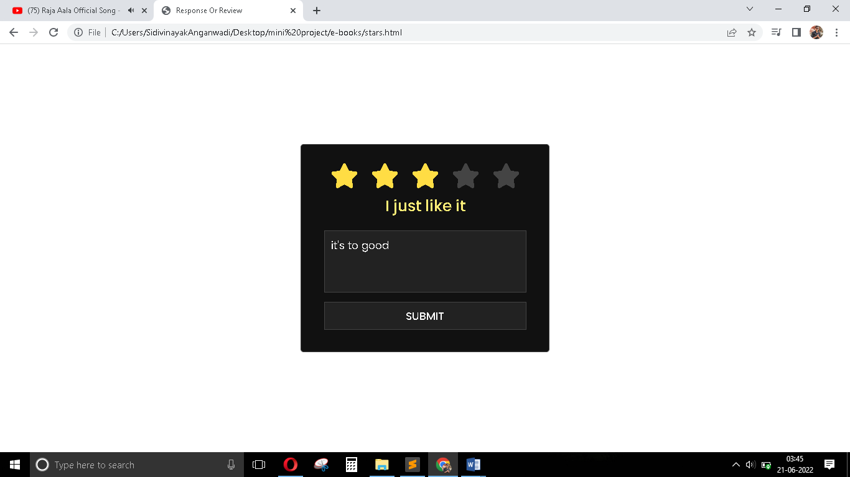

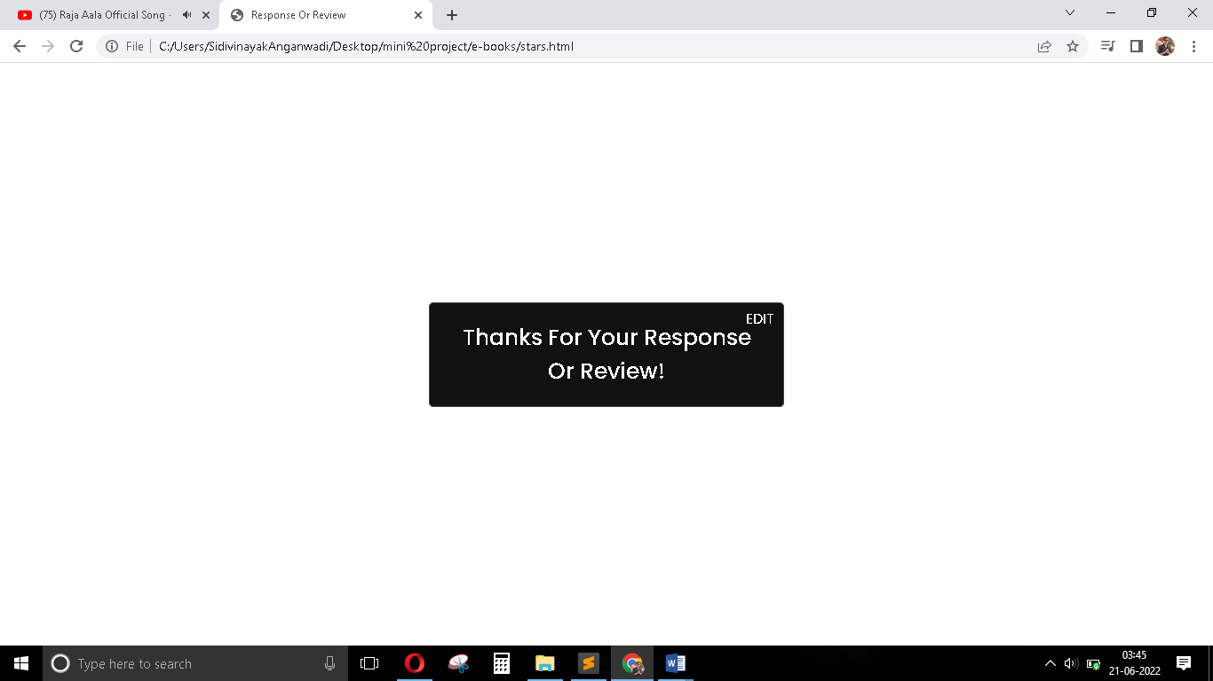

**OUTPUT**

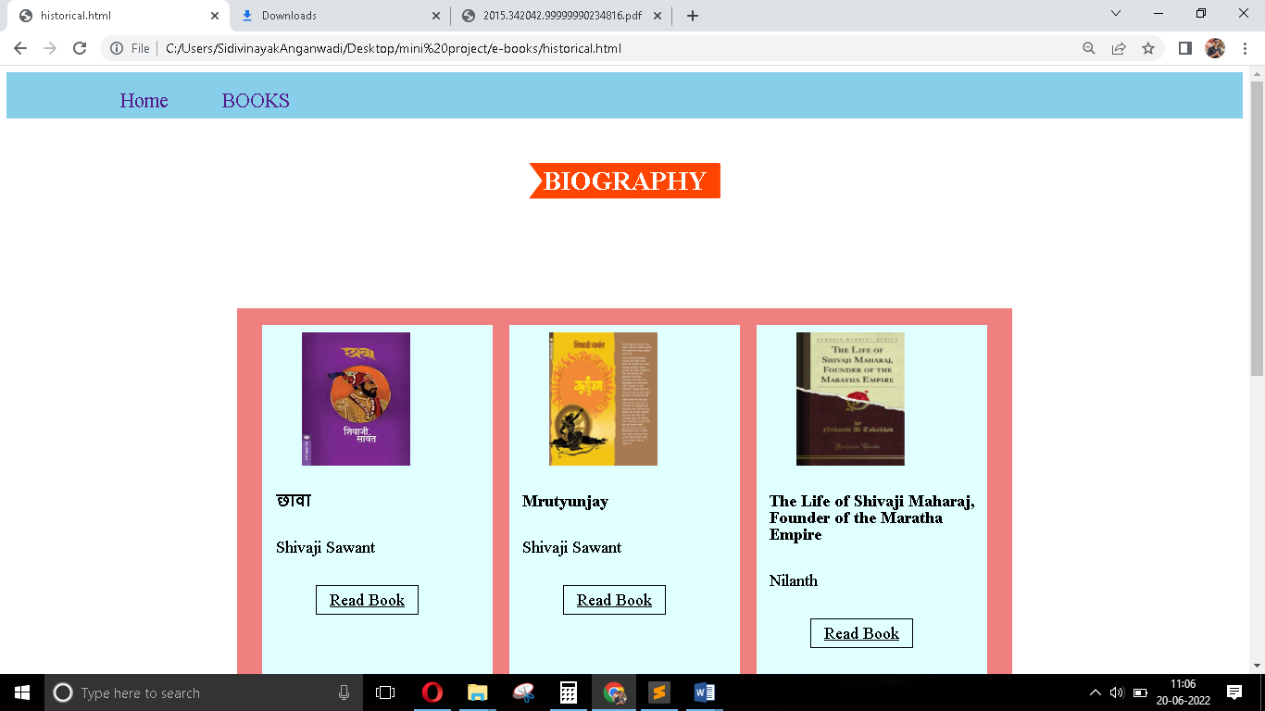

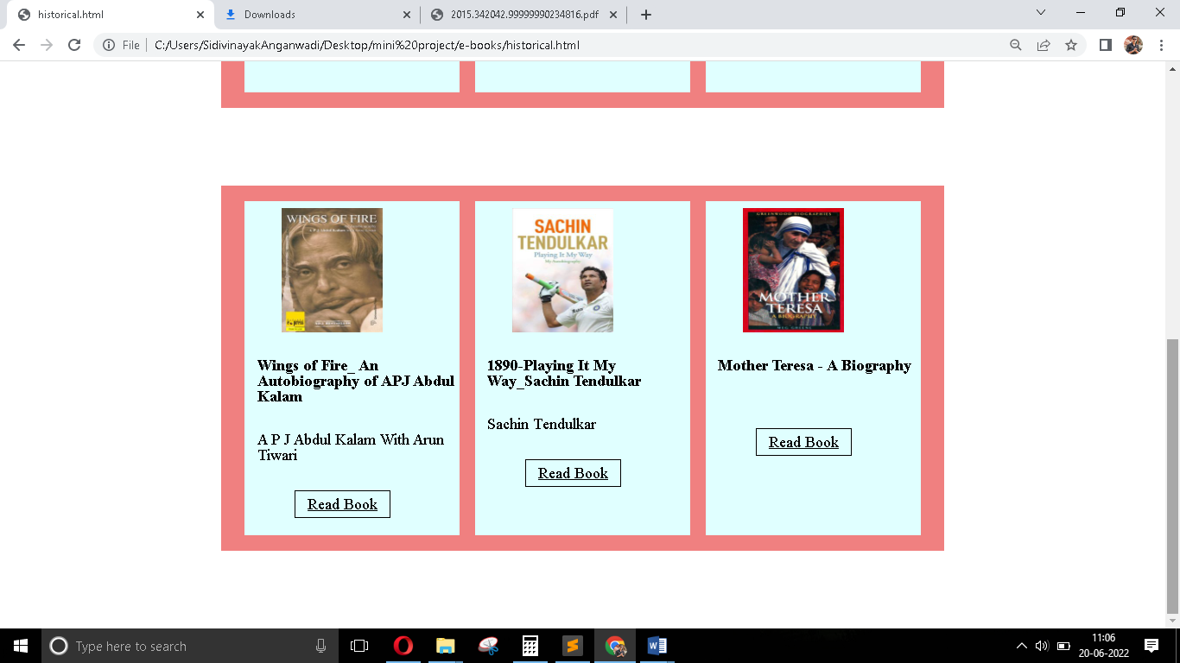

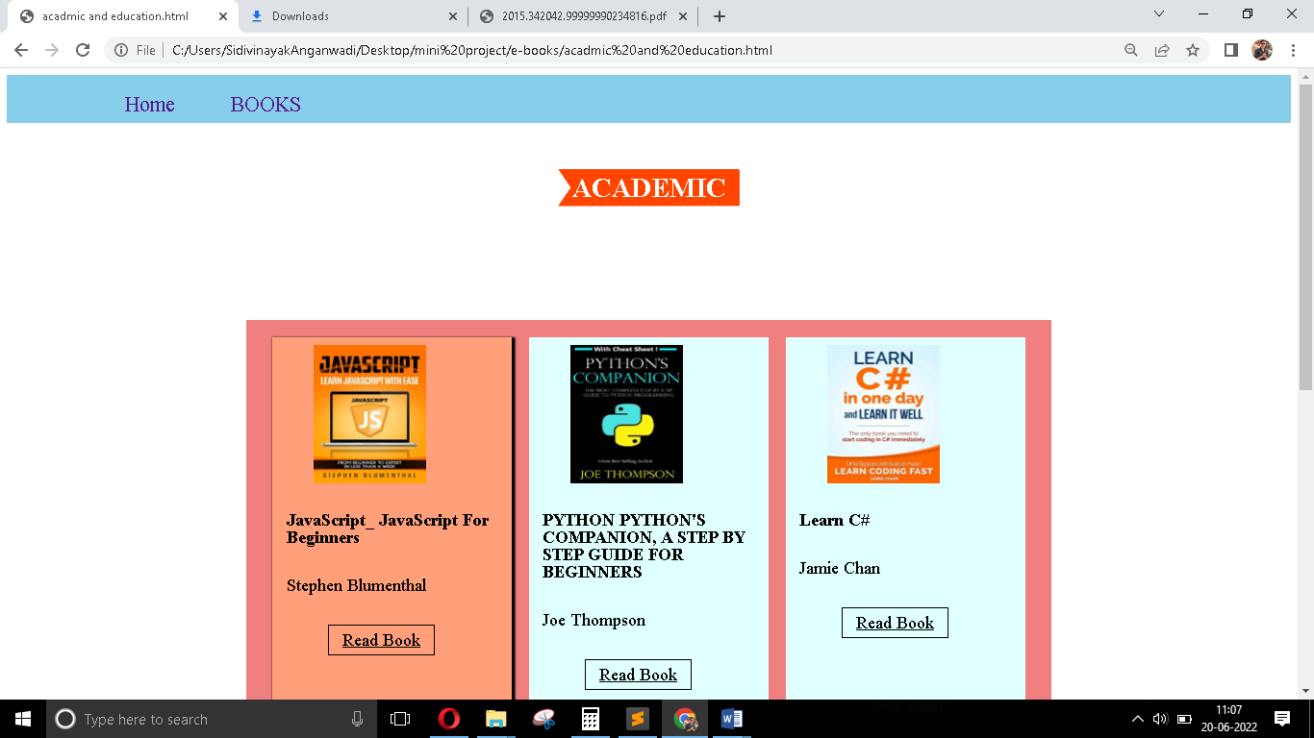

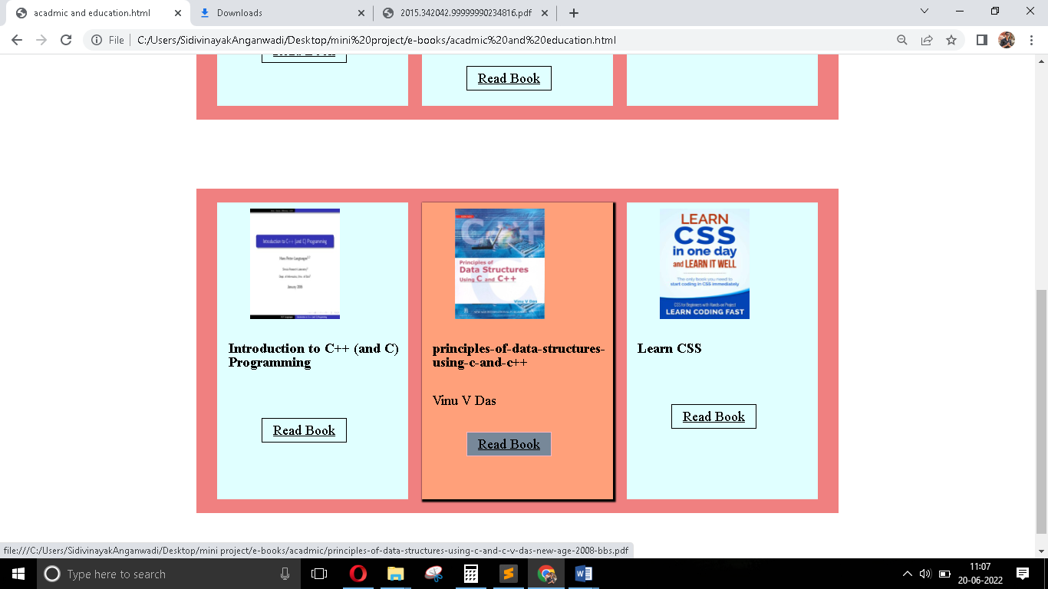

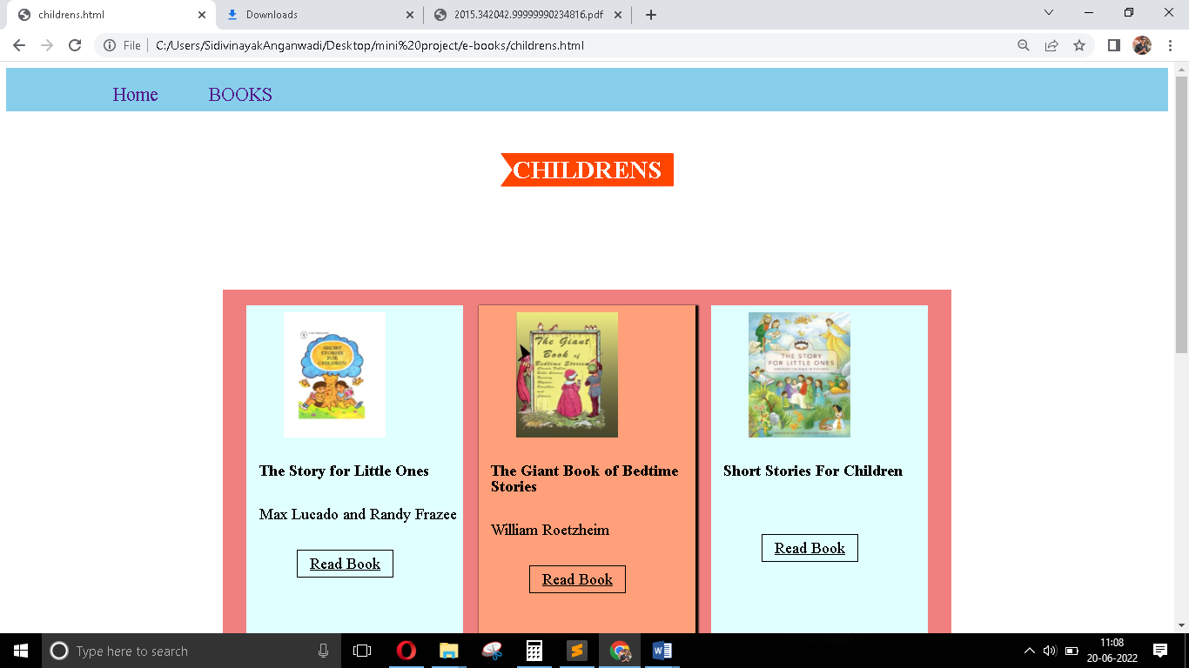

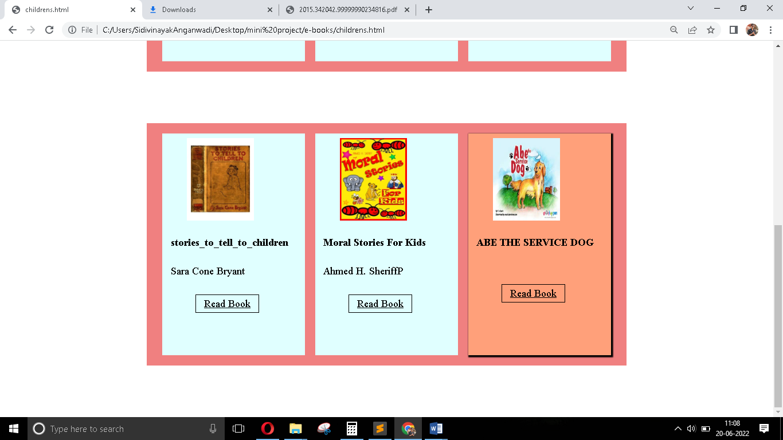

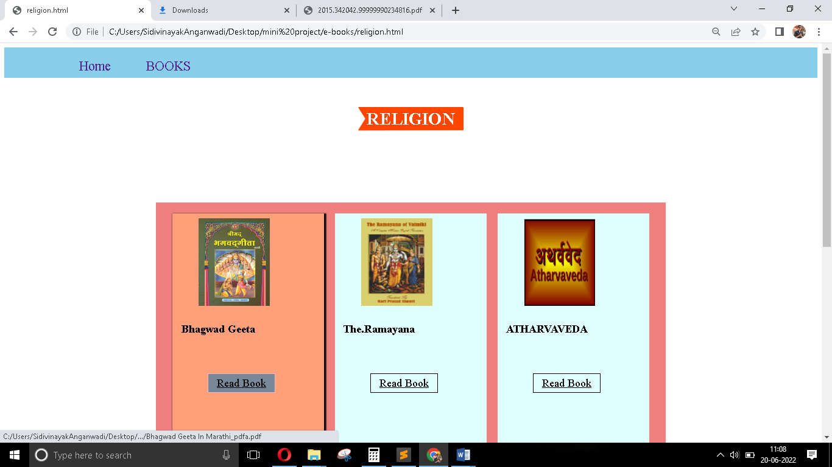

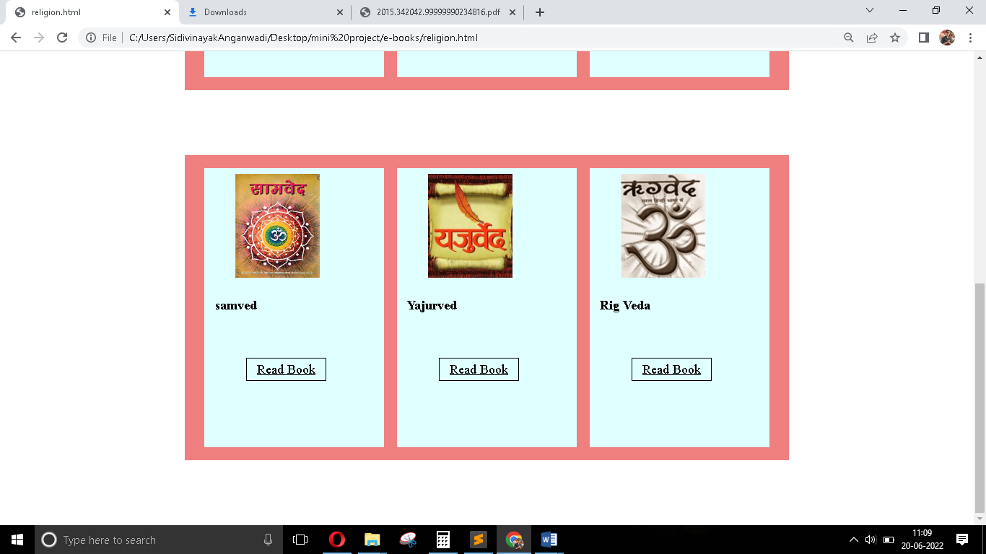

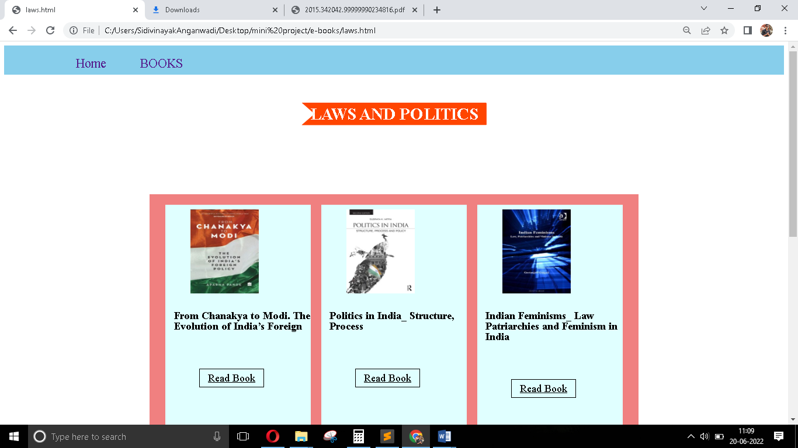

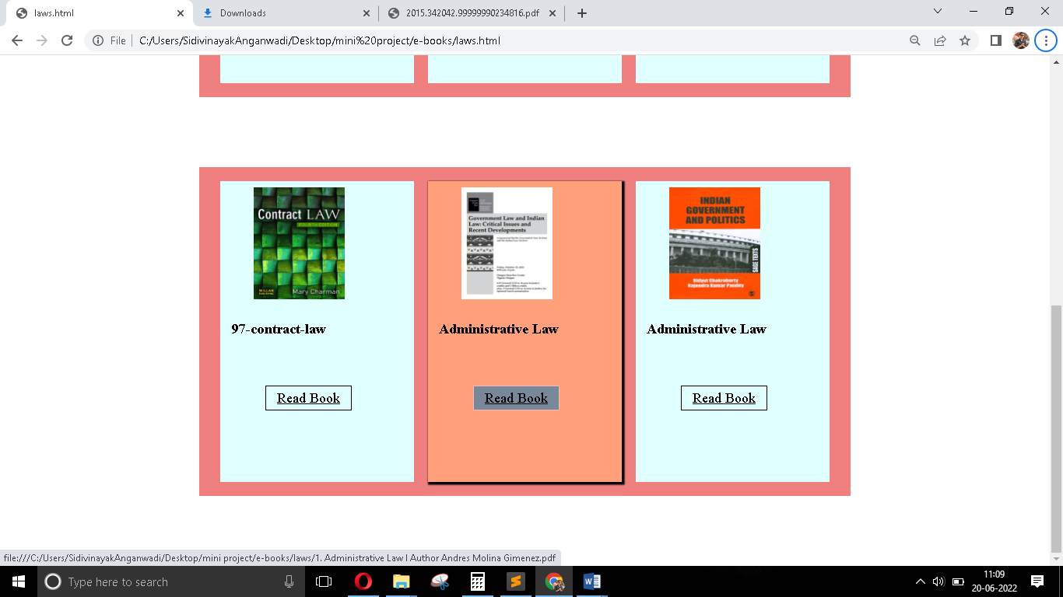

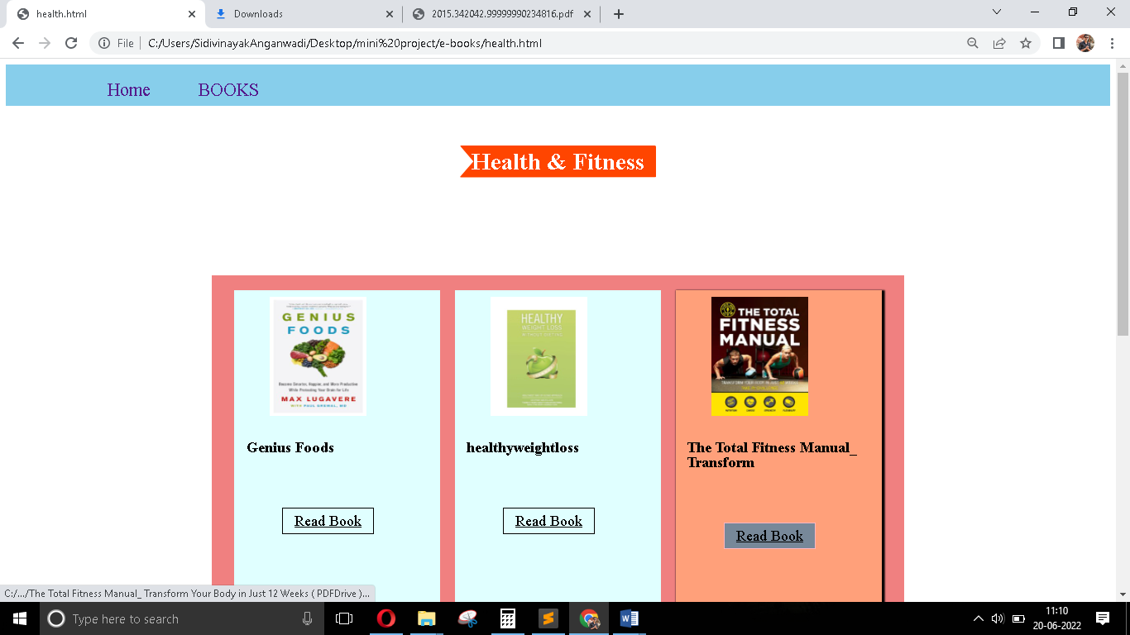

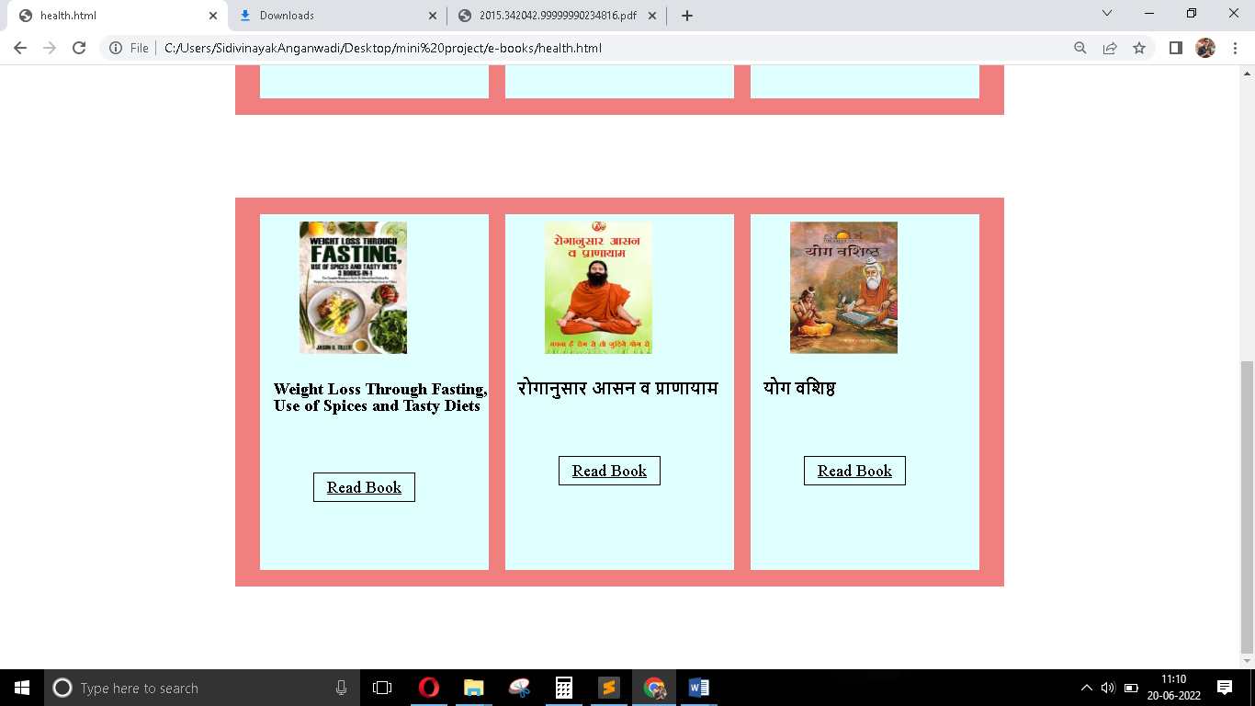

**OUTPUT**

